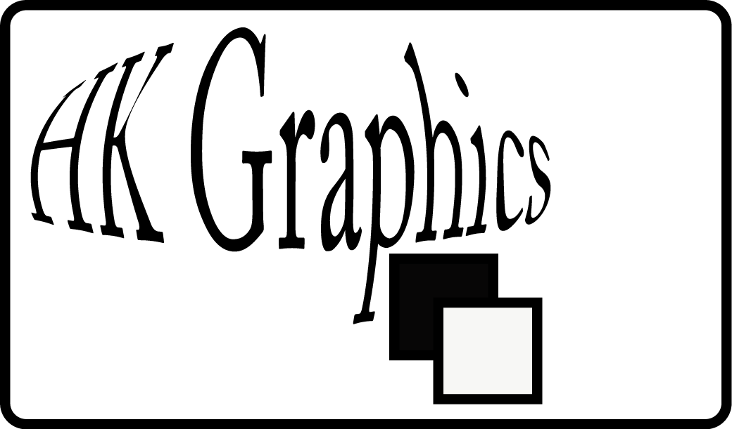
Personal Logo Design

Purpose: The identity of a company, product or corporation can be the most important factor in their long and short term success. The Graphic Logo (Icon) that represents these companies is the most viewed and analyzed piece of information that the company can put forth. It implies the style, quality, class, emotions, products and services of a company. As a company or business your identity can be everything.

Activity:

Create a company name and purpose, and design a logo for your company

- Read the information on Logos from the “Anatomy of a Logo “ and the “Ch6_Logos,Symbols, Pictograms and Stationary Systems” and Answer Question on the Worksheet
- Complete the Logo Pre-Design Worksheet individually
- Brainstorm with a group and come up with possible names, images, solutions for your company
- Create a Company Name
- Create your company logo using vector art and text
- Create 1 Comprehensive Design for each of the following logo styles (you must use the same company name for all):
  - Pictorial Visual
  - Initials
  - Logotype
  - Combination
- Finalize one design from each category.
- Print and Mount your Personal Logo on Black finishing paper with complete with Name, Name of your Company, and Logo
- Update Portfolio
Anatomy of a Logo
&
6. Logos, Symbols, Pictograms, and Stationary Systems

Anatomy of a Logo:

- How many colors do logos typically have?

- Why are colors important to a logo?

- Why is it important to keep logos simple?

- List 4 places/media that a logo might appear on:

- What issue do trendy designs have?

Ch.6 Logos:

- When creating a logo what task are you faced with?

- What qualities should a logo have

- Define the following logo styles:
  - Logotype:
  - Initials:
  - Pictorial Visual:
  - Abstract Visual:
  - Combination:

Symbols

- What is a symbol?

- What are the 3 configurations of symbols?

- What does the use of arrows symbolize in the “Sun Microsystems” designs?

Pictograms

- How do pictograms communicate?

- What Barriers do they cross?

Stationary

- What is the primary purpose of business cards/letterhead?

- What is the secondary function?

- What objects do stationary set consist of?

- What information should be found on them?

Logo Design
Worksheet

RESEARCH

- Find 10 Logos from products or companies that you commonly buy or use. Print them out or cut them out and attach them to this packet (use the web or magazines).
- Label each logo with the following information:
  - Colors used and why?
  - Logo style (logotype, symbolic, initial, symbolic)
  - Symbols/images used and symbolism present

- Which one is your favorite?
  - What do you notice about the logos? (shapes, colors, underlying statements, personality of the company)

- Least Favorite?
  - What do you notice about the logos? (shapes, colors, underlying statements, personality of the company)

- Select a logo from the “Secret Life of Logos” book. Copy the section and answer the following questions:
- What company is the logo for?

- What was the designer trying to accomplish in their own words?

- What symbols and/or hidden symbols are present? What do they represent?

- What colors are present? What moods do they symbolize?

- How are the designs varied? What elements are varied? What logo styles are used?

- How are they kept uniform or consistent?

IDEA GENERATION

1. What are services, products or activities will your company deal with?

2. How do you want your company to be seen? What words, feelings or images do you want to come to people’s minds?

3. What color will best represent your company’s image?

  - Find that color in the “Color: Messages and Meanings,” book. Copy section and Read.
  - List 5 emotions/concepts/feelings that your color represents. Do they match your companies image?

  - Select a pantone from the samples at the end of your section, write it here:

4. Who will your audience be?
Age:
Demographic:
What else do they like?:

5. Who are your competitors?

6. Brainstorm possible names for your company that connect your answers from questions 1, 2 & 3. write the top 5 here

7. List 5 images/symbols that you can draw/design that will help identify your company’s services

8. Sketch 10 Thumbnails for possible personal logos here:
Go Design!!!!!!

Project Name: _______________ Student: _______________

Personal Logo Design Project (Adobe Illustrator)

 | Self | Teacher
- Student has shown a range of styles, ideas, and color schemes (use of creativity) |  | /15
- Student has shown evidence of symbolism and a variety of symbols to represent the product/company/service (Product/Implementation) |  | /10
- Have elements/principles of design been used to construct designs?  - (Use of Knowledge) |  | /5
- Have all four styles of logos been represented in the designs?  - (Use of Knowledge/Use of Creativity) |  | /10
- Advanced Editing/Altering of Text only logos can be seen. Student goes beyond the basic text format/appearance.  - (Product and/or Implementation) |  | /15
- Are the company name and services clearly visualized in the logos?  - (Use of Creativity) |  | /10
- Were Illustrator specific skills used in the making of each logo?  - (Use of Skill) |  | /15
- Have original vector drawing and/or artwork been created for use in the logos?  - (Ethical and/or Responsible Decisions) |  | /15
- Have all aspects of the project been submitted in full and on time?  - (Production/ Implementation) |  | /5
- Student demonstrates independence with software/tools and is able to generate individual ideas without the aid of the teacher (Creativity/Use of skill) |  | /10
Comments:

/110

Apply Information_School Wide Rubric

Criteria | Exceeds Standard | Meets Standard | Approaches Standard | Misses Standard
Use of Skill | Independently demonstrates proficient use of skills in an effective and safe manner | Demonstrates proficient use of skills in a safe and effective manner | Demonstrates safe but partial proficiency in the use of skills. | Does not yet demonstrate proficient use of skills in a safe or effective manner
Use of Knowledge | Makes relevant and insightful connections between prior knowledge and/or experience and new learning/applications. | Makes frequent relevant connections between prior knowledge and/or experience and new learning/applications. | Makes occasional relevant connections between prior knowledge and/or experience and new learning/applications. | Unable to relate prior knowledge and/or experience to new learning/applications.
Production and/or Implementation | Creates an original product or solution that meets the necessary requirements. | Creates a functional product or solution that meets the necessary requirements | Creates a functional product or solution that meets the necessary requirements with assistance | Does not yet create a functional product or solution.
Ethical and/or Responsible Decisions | Demonstrates ethical decision making without prompting by citing sources, utilizing materials ethically and/or apply knowledge in an ethical manner | Demonstrates ethical decision making by citing sources, utilizing materials ethically and/or apply knowledge in an ethical manner | Demonstrates ethical decision making by attempting to cite sources, utilize materials ethically and/or apply knowledge in an ethical manner | Uses materials or knowledge unethically and/or violates copyright law.
Use of Creativity | Develops a novel product or solution that is a coherent expression of the individual’s personal style or ideas | Develops a novel product or solution that incorporates elements of the individual’s personal style or ideas | Develops a product or solution that incorporates elements of the individual’s personal style or ideas | Develops a product or solution that lacks evidence of the individual’s personal style or ideas.

