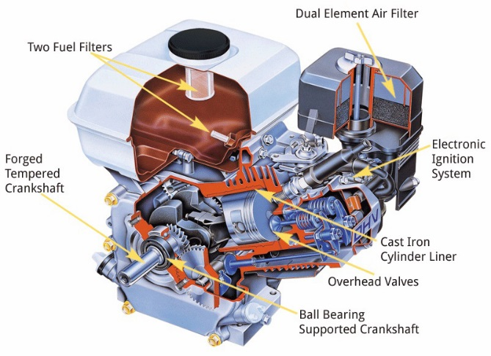
Small Engines: Syllabus

Unit 1: Shop Safety
- Attire, Tool use, Fuels, Storage
- Fire safety

Unit 2: Basic Tools and Engine Tools
- Hand Tool use and Identification | - Specialty tools

Unit 3: Fasteners and Hardware
- Fastener Types and Identification  - Springs, coils, retainers, keys  - Clearances and Feelers | - Tap, Die, Thread gauge uses  - Rulers, Calipers, Micrometers

Unit 4: Electrical
- Basic Circuits  - Using a Multimeter | - Measuring Volts, Amps, Ohms

Unit 5: Small Engine Basics and Components
- 2 stroke vs. 4 Stroke  - Engine parts & components  - Engine variations | - Part Identification  - Pistons, Rods, crankshafts, valves  - Reading Technical Diagrams & Repair docs

Unit 6: Fuel/ Air/ Spark/ Horsepower!!
- Fuel ratios and mixing  - Sparkplugs  - Gaskets and seals | - Calculating and understanding Horsepower

Unit 7: Carburetors
- Carburetor types and function  - Cleaning and repair | - High and Low fuel/air adjustments

Unit 8: Troubleshooting and Repair
- Common Problems  - How to troubleshoot starting problems | - Gasket repair  - Ordering Parts

Unit 9: Special Projects
- Equipment Repair (family/friends)
- Personal project: lawnmower bike, go-kart, custom machine

